Michael Watkins

SNHU CS255

11/12/2023

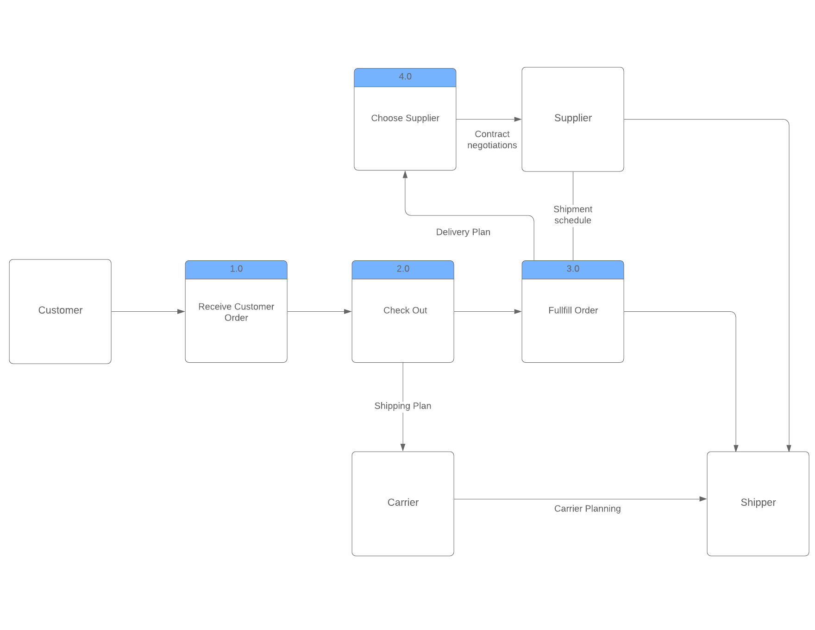

The data flow diagram illustrates the current purchase and supply process for Hamp Crafts' brick-and-mortar store. It shows the flow of information between customers, the store, and suppliers, including how customer orders are received, processed, and fulfilled. The current process includes:

1. **Receiving Customer Orders (1.0)**: This is the initial point of contact with customers where the store receives an order.
2. **Checking Out (2.0)**: At this stage, the order details are checked and processed.
3. **Fulfilling Orders (3.0)**: Here, the store fulfills the order, likely involving checking inventory and preparing the items for dispatch.
4. **Choosing a Supplier (4.0)**: If the inventory is low or out, the store must choose a supplier to restock.

The data sources involved in the current process include:

* The **Customer Order Details**, which contain what has been ordered, the quantity, and customer information.
* An **Inventory System** to check stock levels against the order.
* A **Supplier Database** to manage supplier contacts and order restock items when necessary.
* A **Merchant Account System** to handle transaction funds and ensure they are transferred to the company's primary business account.

For the new online storefront, additional processes would include:

* A **Product Display System** that allows customers to view products online.
* An **Online Payment Gateway** to handle transactions securely.
* An **Order Confirmation System** to automatically confirm orders to customers.
* An **Administrative Backend** for customer support, updating customer information, and website maintenance.

The system would need to access data sources such as:

* **Online Product Catalog** with current stock levels and product information.
* **Customer Profiles** for personalization and order history.
* **Online Transaction Records** for tracking sales and payments.

Additional databases could include:

* An **E-commerce Database** to handle online transactions and customer data.
* A **Content Management System (CMS)** for website updates and product management.
* An **Integration Layer** to sync online sales with the current inventory system.

To integrate the new online storefront into Hamp Crafts' current purchase and supply process, one must consider whether to create a separate system or incorporate it into the current model. Given the need for tight integration between online and in-store inventory, as well as the need for a centralized view of customer orders, it could be more effective to incorporate elements of the online storefront into the current process model. This would allow for unified inventory management and provide a seamless experience for both online and in-store operations. However, this requires ensuring that the current system can scale to handle online transactions and that adequate cybersecurity measures are in place to protect online customer data.